**Homework: Implement Figure 3.10 by programming with Python**

Python Code:

**import** numpy as np

**import** imageio.v2 as imageio

**import** matplotlib

matplotlib.use('TkAgg')

**import** matplotlib.pyplot as plt

**import** os

**def** contrast_stretch(input_image):

    """

    Performs contrast stretching on the input image

    """

    r_min **=** np.min(input_image)

    r_max **=** np.max(input_image)

**if** r_max **==** r_min:

**return** input_image.astype('uint8')

    input_image_float **=** input_image.astype(float)

    output_image **=** (input_image_float **-** r_min) **\*** (255.0 **/** (r_max **-** r_min))

**return** output_image.astype('uint8')

**def** threshold_processing(input_image, threshold_value):

    """

    Performs grayscale thresholding on the image

    """

    output_image **=** np.zeros_like(input_image)

    output_image[input_image >**=** threshold_value] **=** 255

**return** output_image.astype('uint8')

**if** __name__ **==** "__main__":

    image_path **=** "Fig0310(b)(washed_out_pollen_image).tif"

    original_image **=** imageio.imread(image_path)

    stretched_image **=** contrast_stretch(original_image)

    m **=** int(np.mean(original_image))

    thresholded_image **=** threshold_processing(original_image, m)

    # Visualization

    plt.figure(figsize**=**(18, 6))

    plt.subplot(1, 3, 1)

    plt.imshow(original_image, cmap**=**'gray', vmin**=**0, vmax**=**255)

    plt.title(f'Original Image')

    plt.axis('off')

    plt.subplot(1, 3, 2)

    plt.imshow(stretched_image, cmap**=**'gray', vmin**=**0, vmax**=**255)

    plt.title(f'Contrast Stretch Result')

    plt.axis('off')

    plt.subplot(1, 3, 3)

    plt.imshow(thresholded_image, cmap**=**'gray', vmin**=**0, vmax**=**255)

    plt.title(f'Threshold Processing Result')

    plt.axis('off')

    plt.tight_layout()

    output_path **=** "combined_results.png"

    plt.savefig(output_path, bbox_inches**=**'tight')

    imageio.imwrite("Fig0310_stretched.tif", stretched_image)

imageio.imwrite("Fig0310_thresholded.tif", thresholded_image)

Output Images:

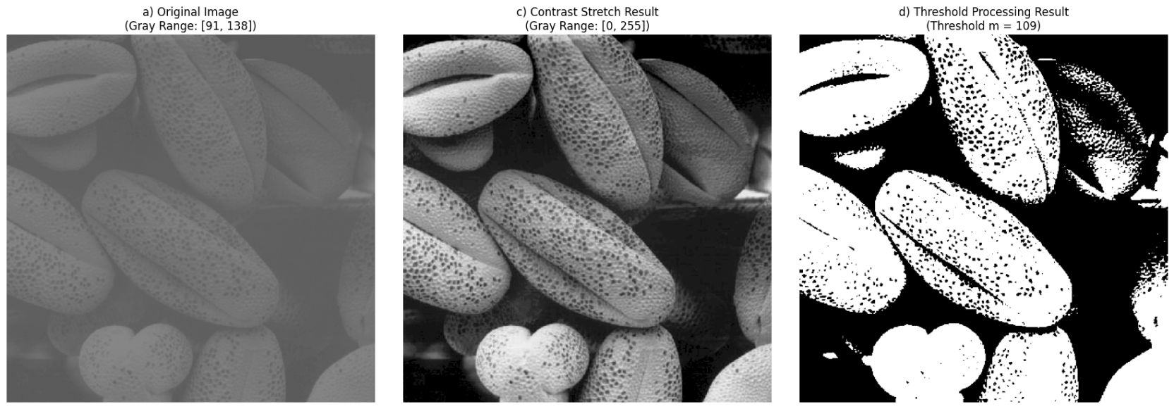

**Homework: Implement Figure 3.14 by programming with Python**

Python Code:

**import** numpy as np

**import** imageio.v2 as imageio

**import** matplotlib

matplotlib.use('Agg')

**import** matplotlib.pyplot as plt

**import** os

**def** bit_plane_slice(input_image, bit_position):

    """

    Extracts a specific bit plane from an 8-bit grayscale image

    """

    bit_plane **=** ((input_image >> bit_position) & 1) **\*** 255

**return** bit_plane.astype('uint8')

**if** __name__ **==** "__main__":

    image_path **=** "./original_image/Fig0314.png"

    output_dir **=** "output_image"

    os.makedirs(output_dir, exist_ok**=**True)

**if** original_image.dtype !**=** np.uint8:

**if** np.max(original_image) > 255:

            original_image **=** (original_image **/** np.max(original_image) **\*** 255).astype(np.uint8)

**else**:

            original_image **=** original_image.astype(np.uint8)

    bit_planes **=** []

**for** i **in** range(8):

        plane **=** bit_plane_slice(original_image, i)

        bit_planes.append(plane)

    # Visualization

    plt.figure(figsize**=**(15, 15))

    plt.subplot(3, 3, 1)

    plt.imshow(original_image, cmap**=**'gray', vmin**=**0, vmax**=**255)

    plt.title('Original Image')

    plt.axis('off')

**for** i **in** range(8):

        bit_plane_idx_for_display **=** 7 **-** i

        plt.subplot(3, 3, i **+** 2)

        plt.imshow(bit_planes[bit_plane_idx_for_display], cmap**=**'gray', vmin**=**0, vmax**=**255)

        plt.title(f'Bit-plane {bit_plane_idx_for_display}')

        plt.axis('off')

    plt.tight_layout()

    combined_output_path **=** os.path.join(output_dir, "Fig0314_bit_planes_combined_MSB_first.png")

    plt.savefig(combined_output_path, bbox_inches**=**'tight')

    print(f"Combined visualization (MSB first) saved to: {combined_output_path}")

**for** i **in** range(8):

        bit_plane_idx_for_save **=** 7 **-** i

        individual_output_path **=** os.path.join(output_dir, f"Fig0314_bit_plane_{bit_plane_idx_for_save}_MSB_first.png")

        imageio.imwrite(individual_output_path, bit_planes[bit_plane_idx_for_save])

        print(f"Bit-plane {bit_plane_idx_for_save} saved to: {individual_output_path}")

Output Images:

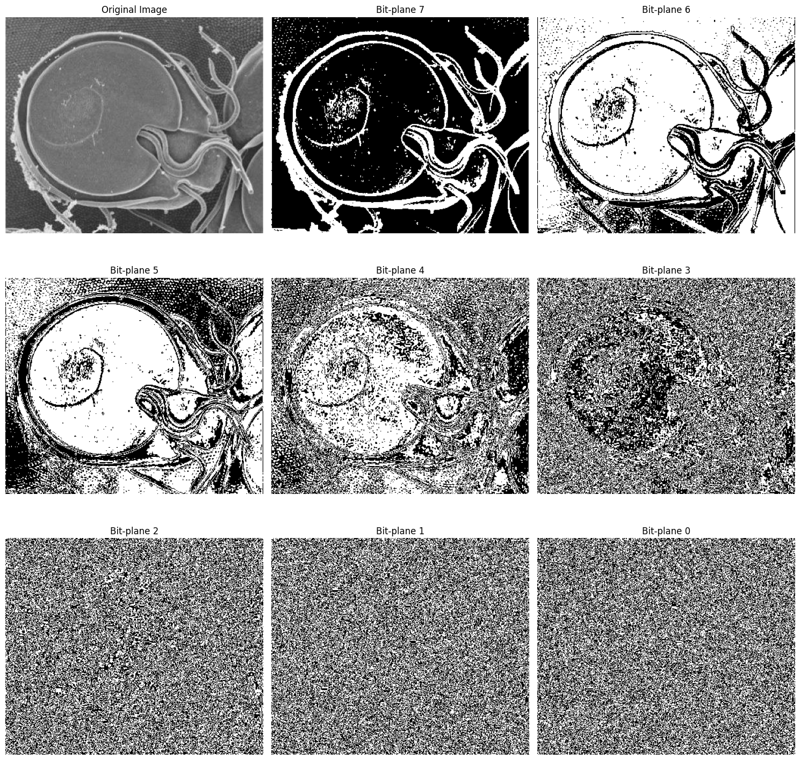

**Homework: Implement Figure 3.20 by programming with Python**

Python Code:

**import** numpy as np

**import** imageio.v2 as imageio

**import** matplotlib

matplotlib.use('Agg')

**import** matplotlib.pyplot as plt

**import** os

**def** calculate_histogram(image, bins**=**256):

    """

    Calculates the histogram of an 8-bit grayscale image.

    """

    hist, _ **=** np.histogram(image.flatten(), bins, [0, bins])

**return** hist

**def** histogram_equalization(image):

    """

    Performs histogram equalization on an 8-bit grayscale image.

    """

    hist **=** calculate_histogram(image)

    cdf **=** hist.cumsum()

    cdf_min **=** cdf.min()

    cdf_max **=** cdf.max()

**if** cdf_max **==** cdf_min:

        equalized_image **=** np.full_like(image, 127, dtype**=**np.uint8)  # Set to mid-gray

**else**:

        cdf_normalized **=** (cdf **-** cdf_min) **\*** 255 **/** (cdf_max **-** cdf_min)

        equalized_image **=** cdf_normalized[image]

**return** equalized_image.astype('uint8')

**if** __name__ **==** "__main__":

    input_dir **=** "original_image"

    output_dir **=** "output_image"

    os.makedirs(output_dir, exist_ok**=**True)

    image_filenames **=** [

        "Fig0320(1)(top_left).tif",

        "Fig0320(2)(2nd_from_top).tif",

        "Fig0320(3)(third_from_top).tif",

        "Fig0320(4)(bottom_left).tif"

    ]

**for** filename **in** image_filenames:

        image_path **=** os.path.join(input_dir, filename)

        base_name **=** os.path.splitext(filename)[0]

        original_image **=** imageio.imread(image_path)

        equalized_image **=** histogram_equalization(original_image)

        original_hist **=** calculate_histogram(original_image)

        equalized_hist **=** calculate_histogram(equalized_image)

        # Visualization

        plt.figure(figsize**=**(12, 10))

        plt.suptitle(f'Histogram Equalization for {filename}', fontsize**=**16)

        plt.subplot(2, 2, 1)

        plt.imshow(original_image, cmap**=**'gray', vmin**=**0, vmax**=**255)

        plt.title('Original Image')

        plt.axis('off')

        plt.subplot(2, 2, 2)

        plt.plot(original_hist, color**=**'black')

        plt.title('Original Histogram')

        plt.xlabel('Gray Level')

        plt.ylabel('Pixel Count')

        plt.xlim([0, 255])

        plt.grid(True, linestyle**=**'--', alpha**=**0.6)

        plt.subplot(2, 2, 3)

        plt.imshow(equalized_image, cmap**=**'gray', vmin**=**0, vmax**=**255)

        plt.title('Equalized Image')

        plt.axis('off')

        plt.subplot(2, 2, 4)

        plt.plot(equalized_hist, color**=**'black')

        plt.title('Equalized Histogram')

        plt.xlabel('Gray Level')

        plt.ylabel('Pixel Count')

        plt.xlim([0, 255])

        plt.grid(True, linestyle**=**'--', alpha**=**0.6)

        plt.tight_layout(rect**=**[0, 0.03, 1, 0.95])

        combined_output_path **=** os.path.join(output_dir, f"{base_name}_equalization_results.png")

        plt.savefig(combined_output_path, bbox_inches**=**'tight')

        plt.close()

        equalized_image_path **=** os.path.join(output_dir, f"{base_name}_equalized.tif")

        imageio.imwrite(equalized_image_path, equalized_image)

Output Images:

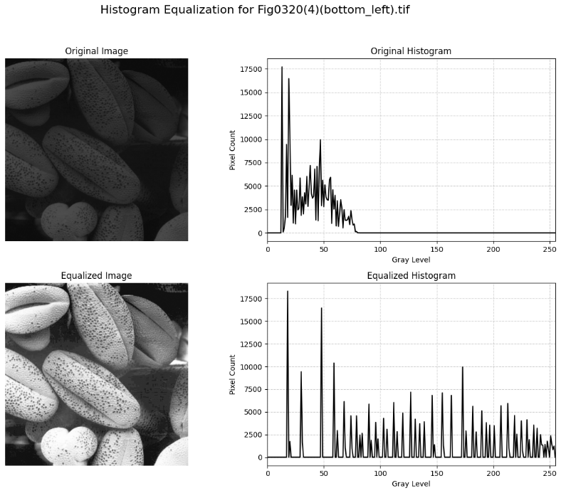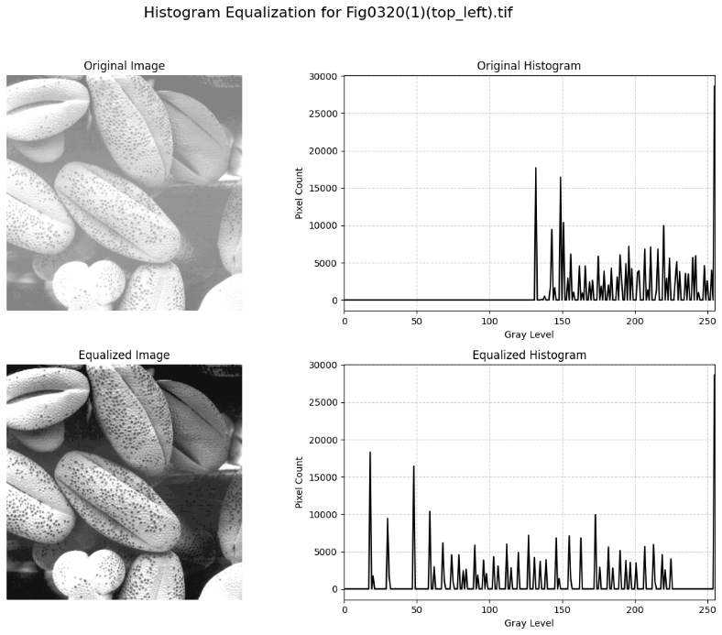

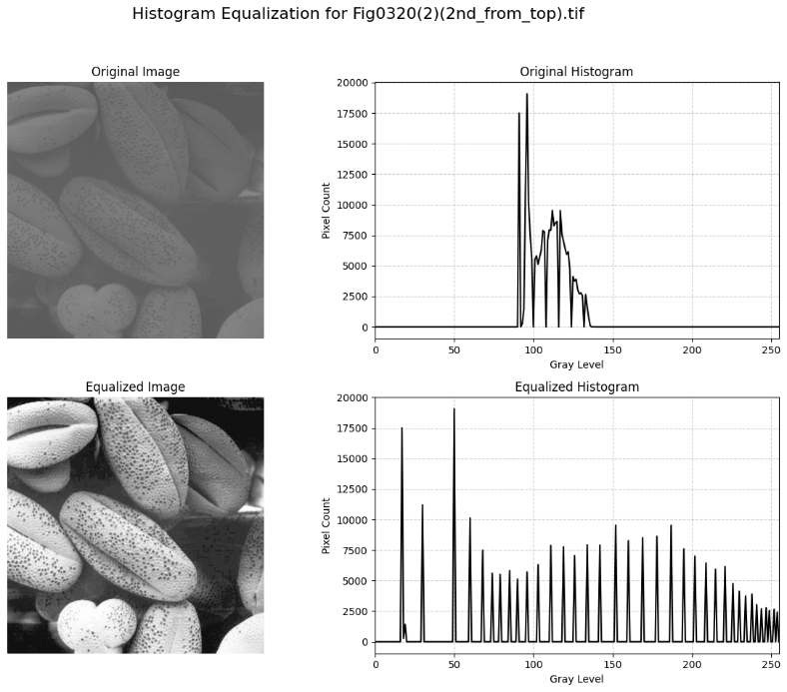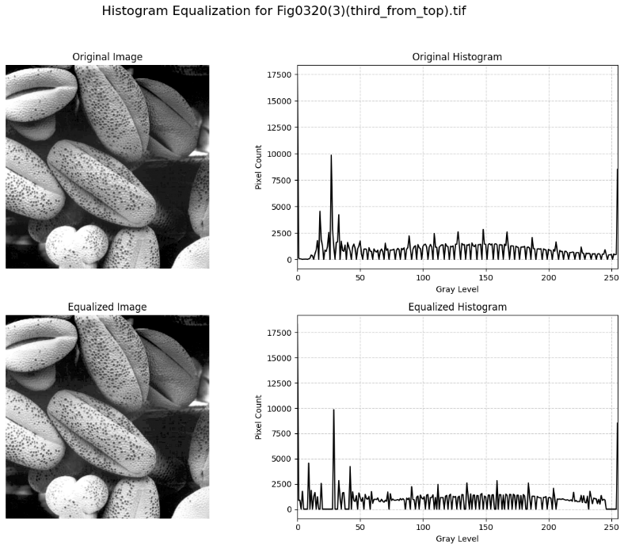

**Homework: Implement Figure 3.24 and 3.25 by programming with Python**

Python Code:

**import** numpy as np

**import** imageio.v2 as imageio

**import** matplotlib

matplotlib.use('Agg')

**import** matplotlib.pyplot as plt

**import** os

**def** calculate_histogram(image, bins**=**256):

    """

    Calculates the histogram of an 8-bit grayscale image

    """

    hist, _ **=** np.histogram(image.flatten(), bins, [0, bins])

**return** hist

**def** histogram_equalization(image):

    """

    Performs histogram equalization on an 8-bit grayscale image

    """

    hist **=** calculate_histogram(image)

    cdf **=** hist.cumsum()

    cdf_min **=** cdf.min()

    cdf_max **=** cdf.max()

**if** cdf_max **==** cdf_min:

        equalized_image **=** np.full_like(image, 127, dtype**=**np.uint8)

        transform_func **=** np.full(256, 127, dtype**=**np.uint8)

**else**:

        transform_func **=** (cdf **-** cdf_min) **\*** 255 **/** (cdf_max **-** cdf_min)

        transform_func **=** transform_func.astype('uint8')

        equalized_image **=** transform_func[image]

**return** equalized_image, transform_func

**def** histogram_specification(input_image, target_histogram):

    """

    Performs histogram specification (matching) on an 8-bit grayscale image

    """

    input_hist **=** calculate_histogram(input_image)

    input_cdf **=** input_hist.cumsum()

    input_cdf_normalized **=** input_cdf **/** input_cdf[**-**1]  # Normalize to [0, 1]

    target_cdf **=** target_histogram.cumsum()

    target_cdf_normalized **=** target_cdf **/** target_cdf[**-**1]  # Normalize to [0, 1]

    lookup_table **=** np.zeros(256, dtype**=**np.uint8)

**for** i **in** range(256):

        j **=** np.searchsorted(target_cdf_normalized, input_cdf_normalized[i], side**=**'left')

        lookup_table[i] **=** min(j, 255)

    specified_image **=** lookup_table[input_image]

**return** specified_image.astype('uint8'), lookup_table

**if** __name__ **==** "__main__":

    input_dir **=** "original_image"

    output_dir **=** "output_image"

    os.makedirs(output_dir, exist_ok**=**True)

    image_filename **=** "Fig0324.png"

    image_path **=** os.path.join(input_dir, image_filename)

    base_name **=** os.path.splitext(image_filename)[0]

    original_image **=** imageio.imread(image_path)

    equalized_image, equalization_transform_func **=** histogram_equalization(original_image)

    target_histogram **=** np.zeros(256, dtype**=**float)

**for** i **in** range(256):

        target_histogram[i] **=** np.exp(**-**i **/** 10.0)

    target_histogram[0:10] **\*=** 5

    target_histogram **=** target_histogram **/** target_histogram.sum() **\*** original_image.size

    specified_image, specification_lookup_table **=** histogram_specification(original_image, target_histogram)

    original_hist **=** calculate_histogram(original_image)

    equalized_hist **=** calculate_histogram(equalized_image)

    specified_hist **=** calculate_histogram(specified_image)

    # Visualization

    plt.figure(figsize**=**(18, 15))  # Adjust figure size for better display

    plt.subplot(3, 3, 1)

    plt.imshow(original_image, cmap**=**'gray', vmin**=**0, vmax**=**255)

    plt.title('a) Original Image')

    plt.axis('off')

    plt.subplot(3, 3, 2)

    plt.plot(original_hist, color**=**'black')

    plt.title('b) Original Histogram')

    plt.xlabel('Gray Level')

    plt.ylabel('Pixel Count')

    plt.xlim([0, 255])

    plt.grid(True, linestyle**=**'--', alpha**=**0.6)

    plt.subplot(3, 3, 3)

    plt.plot(target_histogram, color**=**'red')

    plt.title('Target Histogram $p_z(z)$')

    plt.xlabel('Gray Level')

    plt.ylabel('Pixel Count')

    plt.xlim([0, 255])

    plt.grid(True, linestyle**=**'--', alpha**=**0.6)

    plt.subplot(3, 3, 4)

    plt.imshow(equalized_image, cmap**=**'gray', vmin**=**0, vmax**=**255)

    plt.title('c) Equalized Image')

    plt.axis('off')

    plt.subplot(3, 3, 5)

    plt.plot(equalized_hist, color**=**'black')

    plt.title('d) Equalized Histogram')

    plt.xlabel('Gray Level')

    plt.ylabel('Pixel Count')

    plt.xlim([0, 255])

    plt.grid(True, linestyle**=**'--', alpha**=**0.6)

    plt.subplot(3, 3, 6)

    plt.plot(np.arange(256), equalization_transform_func, color**=**'blue')

    plt.plot([0, 255], [0, 255], 'k--', alpha**=**0.7, label**=**'Identity')

    plt.title('e) Equalization Transform $T(r)$')

    plt.xlabel('Input Gray Level $r$')

    plt.ylabel('Output Gray Level $s$')

    plt.xlim([0, 255])

    plt.ylim([0, 255])

    plt.grid(True, linestyle**=**'--', alpha**=**0.6)

    plt.legend()

    plt.subplot(3, 3, 7)

    plt.imshow(specified_image, cmap**=**'gray', vmin**=**0, vmax**=**255)

    plt.title('f) Specified Image')

    plt.axis('off')

    plt.subplot(3, 3, 8)

    plt.plot(specified_hist, color**=**'black')

    plt.title('g) Specified Histogram')

    plt.xlabel('Gray Level')

    plt.ylabel('Pixel Count')

    plt.xlim([0, 255])

    plt.grid(True, linestyle**=**'--', alpha**=**0.6)

    plt.subplot(3, 3, 9)

    target_cdf_normalized_for_plot **=** target_histogram.cumsum() **/** target_histogram.cumsum()[**-**1] **\*** 255

    plt.plot(np.arange(256), target_cdf_normalized_for_plot, color**=**'green', label**=**'$G(z)$ (Target CDF)')

    plt.plot(np.arange(256), specification_lookup_table, color**=**'purple', linestyle**=**'--', label**=**'$G^{-1}(s)$ (Mapping)')

    plt.plot([0, 255], [0, 255], 'k--', alpha**=**0.7, label**=**'Identity')  # Identity line

    plt.title('h) Specification Transforms')

    plt.xlabel('Input Gray Level')

    plt.ylabel('Output Gray Level')

    plt.xlim([0, 255])

    plt.ylim([0, 255])

    plt.grid(True, linestyle**=**'--', alpha**=**0.6)

    plt.legend()

    plt.tight_layout(rect**=**[0, 0.03, 1, 0.97])

    combined_output_path **=** os.path.join(output_dir, f"{base_name}_hist_comparison_results.png")

    plt.savefig(combined_output_path, bbox_inches**=**'tight')

    plt.close()

Output Images:

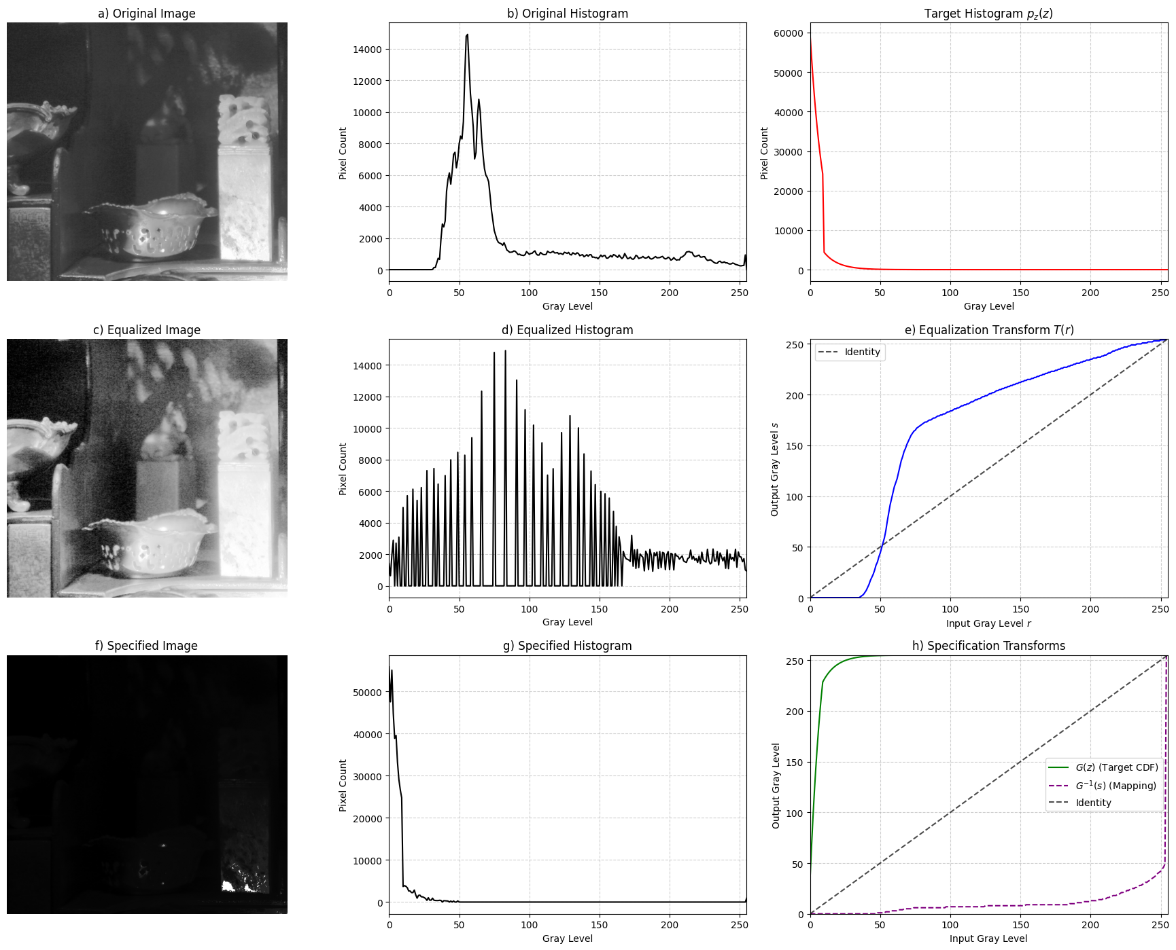

**Homework: Implement Figure 3.26 by programming with Python**

Python Code:

**import** numpy as np

**import** imageio.v2 as imageio

**import** matplotlib

matplotlib.use('Agg')

**import** matplotlib.pyplot as plt

**import** os

**def** histogram_equalization_global(image):

    """

    Performs global histogram equalization on an 8-bit grayscale image

    """

    hist, _ **=** np.histogram(image.flatten(), bins**=**256, range**=**[0, 256])

    cdf **=** hist.cumsum()

    cdf_min **=** cdf.min()

    cdf_max **=** cdf.max()

**if** cdf_max **==** cdf_min:

        equalized_image **=** np.full_like(image, 127, dtype**=**np.uint8)

**else**:

        transform_func **=** (cdf **-** cdf_min) **\*** 255 **/** (cdf_max **-** cdf_min)

        transform_func **=** transform_func.astype('uint8')

        equalized_image **=** transform_func[image]

**return** equalized_image

**def** local_histogram_equalization(image, kernel_size**=**3):

    """

    Performs local histogram equalization on an 8-bit grayscale image

    """

    H, W **=** image.shape

    output_image **=** np.zeros_like(image, dtype**=**np.uint8)

    pad_size **=** kernel_size **//** 2

    padded_image **=** np.pad(image, pad_size, mode**=**'edge')

**for** r **in** range(H):

**for** c **in** range(W):

            neighborhood **=** padded_image[r: r **+** kernel_size, c: c **+** kernel_size]

            local_hist, _ **=** np.histogram(neighborhood.flatten(), bins**=**256, range**=**[0, 256])

            local_cdf **=** local_hist.cumsum()

            cdf_min **=** local_cdf.min()

            cdf_max **=** local_cdf.max()

**if** cdf_max **==** cdf_min:

                output_image[r, c] **=** image[r, c]

**else**:

                pixel_value **=** image[r, c]

                s **=** (local_cdf[pixel_value] **-** cdf_min) **\*** 255 **/** (cdf_max **-** cdf_min)

                output_image[r, c] **=** np.clip(s, 0, 255).astype(np.uint8)

**return** output_image

**if** __name__ **==** "__main__":

    input_dir **=** "original_image"

    output_dir **=** "output_image"

    os.makedirs(output_dir, exist_ok**=**True)

    image_filename **=** "Fig0326(a)(embedded_square_noisy_512).tif"

    image_path **=** os.path.join(input_dir, image_filename)

    base_name **=** os.path.splitext(image_filename)[0]

    original_image**=** imageio.imread(image_path)

    global_equalized_image **=** histogram_equalization_global(original_image)

    print("Performed global histogram equalization.")

    kernel_size **=** 3

    local_equalized_image **=** local_histogram_equalization(original_image, kernel_size**=**kernel_size)

    # Visualization

    plt.figure(figsize**=**(18, 6))

    plt.suptitle(f'Histogram Equalization Comparison for {image_filename}', fontsize**=**16)

    plt.subplot(1, 3, 1)

    plt.imshow(original_image, cmap**=**'gray', vmin**=**0, vmax**=**255)

    plt.title('a) Original Image')

    plt.axis('off')

    plt.subplot(1, 3, 2)

    plt.imshow(global_equalized_image, cmap**=**'gray', vmin**=**0, vmax**=**255)

    plt.title('b) Global Histogram Equalization')

    plt.axis('off')

    plt.subplot(1, 3, 3)

    plt.imshow(local_equalized_image, cmap**=**'gray', vmin**=**0, vmax**=**255)

    plt.title(f'c) Local Histogram Equalization ({kernel_size}x{kernel_size} neighborhood)')

    plt.axis('off')

    plt.tight_layout(rect**=**[0, 0.03, 1, 0.95])

    combined_output_path **=** os.path.join(output_dir, f"{base_name}_hist_eq_comparison.png")

    plt.savefig(combined_output_path, bbox_inches**=**'tight')

    plt.close()

Output Images:

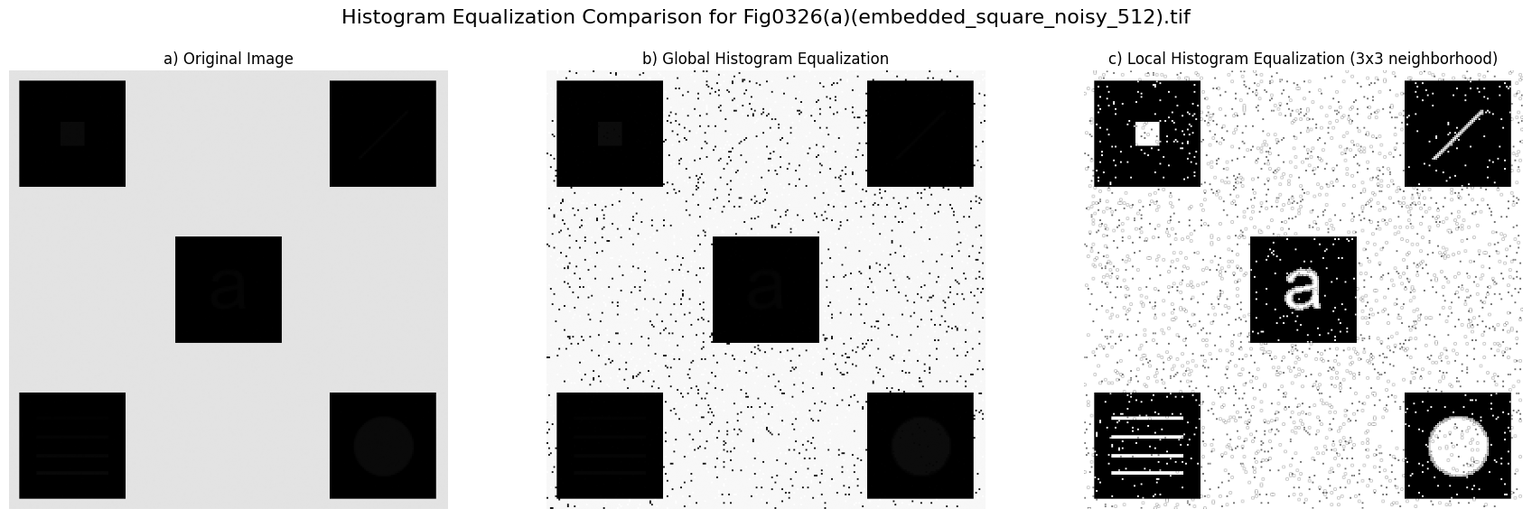

**Homework: Implement Figure 3.27 by programming with Python**

Python Code:

**import** numpy as np

**import** imageio.v2 as imageio

**import** matplotlib

matplotlib.use('Agg')

**import** matplotlib.pyplot as plt

**import** os

**def** local_contrast_enhancement(image, kernel_size**=**3, k0**=**0.4, k1**=**0.02, E**=**4.0):

    """

    Performs local contrast enhancement based on local mean and standard deviation

    """

    H, W **=** image.shape

    output_image **=** np.zeros_like(image, dtype**=**np.uint8)

    pad_size **=** kernel_size **//** 2

    padded_image **=** np.pad(image, pad_size, mode**=**'edge')

    M **=** np.mean(image)

    sigma **=** np.std(image)

    image_float **=** image.astype(float)

    padded_image_float **=** padded_image.astype(float)

**for** r **in** range(H):

**for** c **in** range(W):

            neighborhood **=** padded_image_float[r: r **+** kernel_size, c: c **+** kernel_size]

            m_xy **=** np.mean(neighborhood)

            sigma_xy **=** np.std(neighborhood)

            f_xy **=** image_float[r, c]

**if** m_xy <**=** k0 **\*** M **and** sigma_xy <**=** k1 **\*** sigma:

                g_xy **=** E **\*** f_xy

**else**:

                g_xy **=** f_xy

            output_image[r, c] **=** np.clip(g_xy, 0, 255).astype(np.uint8)

**return** output_image

**if** __name__ **==** "__main__":

    input_dir **=** "original_image"

    output_dir **=** "output_image"

    os.makedirs(output_dir, exist_ok**=**True)

    image_filename **=** "Fig0326(a)(embedded_square_noisy_512).tif"

    image_path **=** os.path.join(input_dir, image_filename)

    base_name **=** os.path.splitext(image_filename)[0]

    original_image **=** imageio.imread(image_path)

    kernel_size **=** 3

    k0 **=** 0.4

    k1 **=** 0.02

    E **=** 4.0

    # Visualization

    plt.figure(figsize**=**(12, 6))  # Adjust figure size for 1x2 layout

    plt.suptitle(f'Local Contrast Enhancement (Example 3.10) for {image_filename}', fontsize**=**16)

    plt.subplot(1, 2, 1)

    plt.imshow(original_image, cmap**=**'gray', vmin**=**0, vmax**=**255)

    plt.title('a) Original Image')

    plt.axis('off')

    plt.subplot(1, 2, 2)

    plt.imshow(enhanced_image, cmap**=**'gray', vmin**=**0, vmax**=**255)

    plt.title(f'b) Enhanced Image (k0={k0}, k1={k1}, E={E})')

    plt.axis('off')

    plt.tight_layout(rect**=**[0, 0.03, 1, 0.95])  # Adjust layout to prevent title overlap

    combined_output_path **=** os.path.join(output_dir, f"{base_name}_local_enhancement_results.png")

    plt.savefig(combined_output_path, bbox_inches**=**'tight')

Output Images:

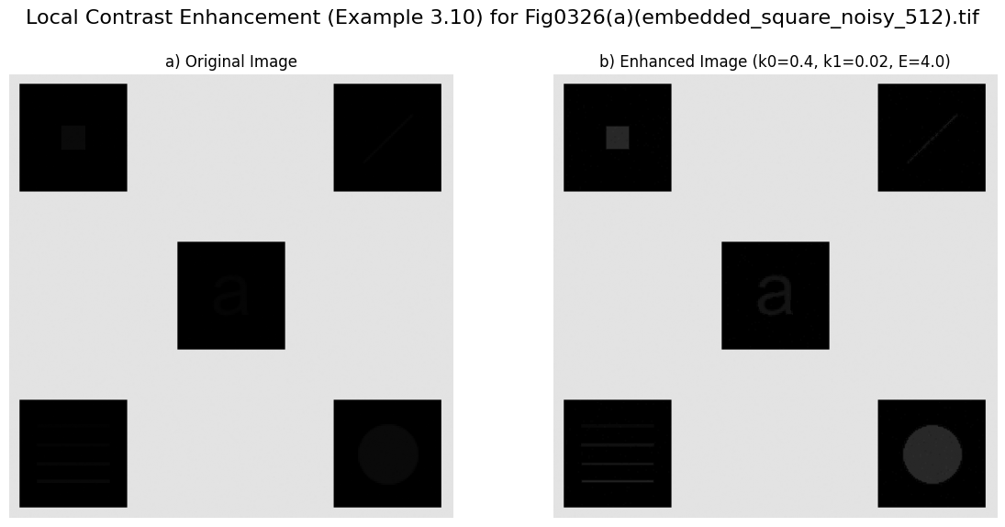

**Homework: Implement Figure 3.33 by programming with Python**

Python Code:

**import** numpy as np

**import** imageio.v2 as imageio

**import** matplotlib

matplotlib.use('Agg')

**import** matplotlib.pyplot as plt

**import** os

**from** scipy.ndimage **import** convolve

**def** apply_box_filter(image, kernel_size):

    """

    Applies a box (average) filter to the image using zero padding

    """

    kernel **=** np.ones((kernel_size, kernel_size), dtype**=**float) **/** (kernel_size **\*** kernel_size)

    image_float **=** image.astype(float)

    filtered_image_float **=** convolve(image_float, kernel, mode**=**'constant', cval**=**0.0)

    filtered_image **=** np.clip(filtered_image_float, 0, 255).astype(np.uint8)

**return** filtered_image

**if** __name__ **==** "__main__":

    input_dir **=** "original_image"

    output_dir **=** "output_image"

    os.makedirs(output_dir, exist_ok**=**True)

    image_filename **=** "Fig0333(a)(test_pattern_blurring_orig).tif"

    image_path **=** os.path.join(input_dir, image_filename)

    base_name **=** os.path.splitext(image_filename)[0]

    original_image **=** imageio.imread(image_path)

    kernel_sizes **=** [3, 11, 21]

    filtered_images **=** {}

**for** k_size **in** kernel_sizes:

        filtered_img **=** apply_box_filter(original_image, k_size)

        filtered_images[k_size] **=** filtered_img

    # Visualization

    plt.figure(figsize**=**(12, 12))

    plt.suptitle(f'Box Filtering Results for {image_filename}', fontsize**=**16)

    plt.subplot(2, 2, 1)

    plt.imshow(original_image, cmap**=**'gray', vmin**=**0, vmax**=**255)

    plt.title('a) Original Image')

    plt.axis('off')

    plt.subplot(2, 2, 2)

    plt.imshow(filtered_images[3], cmap**=**'gray', vmin**=**0, vmax**=**255)

    plt.title('b) Box Filter (3x3)')

    plt.axis('off')

    plt.subplot(2, 2, 3)

    plt.imshow(filtered_images[11], cmap**=**'gray', vmin**=**0, vmax**=**255)

    plt.title('c) Box Filter (11x11)')

    plt.axis('off')

    plt.subplot(2, 2, 4)

    plt.imshow(filtered_images[21], cmap**=**'gray', vmin**=**0, vmax**=**255)

    plt.title('d) Box Filter (21x21)')

    plt.axis('off')

    plt.tight_layout(rect**=**[0, 0.03, 1, 0.95])

    combined_output_path **=** os.path.join(output_dir, f"{base_name}_box_filter_results.png")

    plt.savefig(combined_output_path, bbox_inches**=**'tight')

    plt.close()

Output Images:

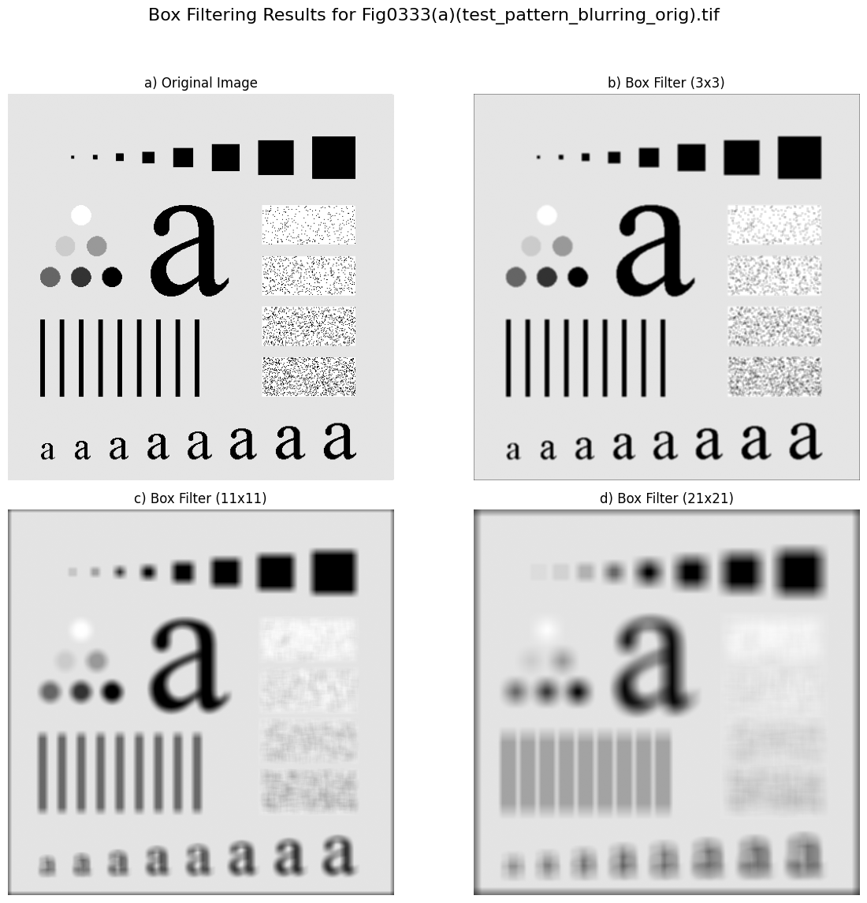

**Homework: Implement Figure 3.33 by programming with Python**

Python Code:

**import** numpy as np

**import** imageio.v2 as imageio

**import** matplotlib

matplotlib.use('Agg')

**import** matplotlib.pyplot as plt

**import** os

**from** scipy.ndimage **import** gaussian_filter, median_filter

**if** __name__ **==** "__main__":

    input_dir **=** "original_image"

    output_dir **=** "output_image"

    os.makedirs(output_dir, exist_ok**=**True)

    image_filename **=** "Fig0335(a)(ckt_board_saltpep_prob_pt05).tif"

    image_path **=** os.path.join(input_dir, image_filename)

    base_name **=** os.path.splitext(image_filename)[0]

    original_image **=** imageio.imread(image_path)

    gaussian_sigma **=** 3

    gaussian_filtered_image **=** gaussian_filter(original_image, sigma**=**gaussian_sigma)

    gaussian_filtered_image **=** np.clip(gaussian_filtered_image, 0, 255).astype(np.uint8)

    median_kernel_size **=** 7

    median_filtered_image **=** median_filter(original_image, size**=**median_kernel_size)

    # Visualization

    plt.figure(figsize**=**(18, 6))

    plt.suptitle(f'Noise Filtering Comparison for {image_filename}', fontsize**=**16)

    plt.subplot(1, 3, 1)

    plt.imshow(original_image, cmap**=**'gray', vmin**=**0, vmax**=**255)

    plt.title('a) Original Image (Salt-and-Pepper Noise)')

    plt.axis('off')

    plt.subplot(1, 3, 2)

    plt.imshow(gaussian_filtered_image, cmap**=**'gray', vmin**=**0, vmax**=**255)

    plt.title(f'b) Gaussian Filter ($\\sigma={gaussian_sigma}$)')

    plt.axis('off')

    plt.subplot(1, 3, 3)

    plt.imshow(median_filtered_image, cmap**=**'gray', vmin**=**0, vmax**=**255)

    plt.title(f'c) Median Filter ({median_kernel_size}x{median_kernel_size})')

    plt.axis('off')

    plt.tight_layout(rect**=**[0, 0.03, 1, 0.95])

    combined_output_path **=** os.path.join(output_dir, f"{base_name}_noise_filtering_results.png")

    plt.savefig(combined_output_path, bbox_inches**=**'tight')

    plt.close()

Output Images:

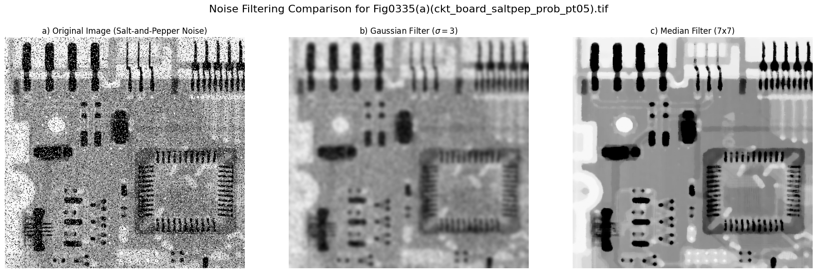

**Homework: Implement Figure 3.46 by programming with Python**

Python Code:

**import** numpy as np

**import** imageio.v2 as imageio

**import** matplotlib

matplotlib.use('Agg')

**import** matplotlib.pyplot as plt

**import** os

**from** scipy.ndimage **import** convolve

**def** apply_laplacian_sharpening(image, laplacian_kernel, c**=-**1):

    """

    Applies a Laplacian filter to an image and then sharpens it

    """

    laplacian_response **=** convolve(image_float, laplacian_kernel, mode**=**'nearest', cval**=**0.0)

    laplacian_image_display **=** np.clip(laplacian_response, 0, 255).astype(np.uint8)

    sharpened_image_float **=** image_float **+** c **\*** laplacian_response

    sharpened_image **=** np.clip(sharpened_image_float, 0, 255).astype(np.uint8)

**return** laplacian_image_display, sharpened_image

**if** __name__ **==** "__main__":

    input_dir **=** "original_image"

    output_dir **=** "output_image"

    os.makedirs(output_dir, exist_ok**=**True)

    image_filename **=** "Fig0338(a)(blurry_moon).tif"

    image_path **=** os.path.join(input_dir, image_filename)

    base_name **=** os.path.splitext(image_filename)[0]

    original_image **=** imageio.imread(image_path)

    laplacian_kernel_a **=** np.array([

        [0, 1, 0],

        [1, **-**4, 1],

        [0, 1, 0]

    ], dtype**=**float)

    laplacian_kernel_b **=** np.array([

        [1, 1, 1],

        [1, **-**8, 1],

        [1, 1, 1]

    ], dtype**=**float)

    laplacian_img_a_display, sharpened_img_a **=** apply_laplacian_sharpening(original_image, laplacian_kernel_a, c**=-**1)

    laplacian_img_b_display, sharpened_img_b **=** apply_laplacian_sharpening(original_image, laplacian_kernel_b, c**=-**1)

    # Visualization

    plt.figure(figsize**=**(15, 12))  # Adjust figure size for 2x2 layout

    plt.suptitle(f'Laplacian Sharpening for {image_filename}', fontsize**=**16)

    plt.subplot(2, 2, 1)

    plt.imshow(original_image, cmap**=**'gray', vmin**=**0, vmax**=**255)

    plt.title('a) Original Blurry Moon Image')

    plt.axis('off')

    plt.subplot(2, 2, 2)

    plt.imshow(laplacian_img_a_display, cmap**=**'gray', vmin**=**0, vmax**=**255)

    plt.title('b) Laplacian Image (Kernel a, clipped)')

    plt.axis('off')

    plt.subplot(2, 2, 3)

    plt.imshow(sharpened_img_a, cmap**=**'gray', vmin**=**0, vmax**=**255)

    plt.title('c) Sharpened Image (Kernel a, $c=-1$)')

    plt.axis('off')

    plt.subplot(2, 2, 4)

    plt.imshow(sharpened_img_b, cmap**=**'gray', vmin**=**0, vmax**=**255)

    plt.title('d) Sharpened Image (Kernel b, $c=-1$)')

    plt.axis('off')

    plt.tight_layout(rect**=**[0, 0.03, 1, 0.95])

    combined_output_path **=** os.path.join(output_dir, f"{base_name}_laplacian_sharpening_results.png")

    plt.savefig(combined_output_path, bbox_inches**=**'tight')

    plt.close()

Output Images:

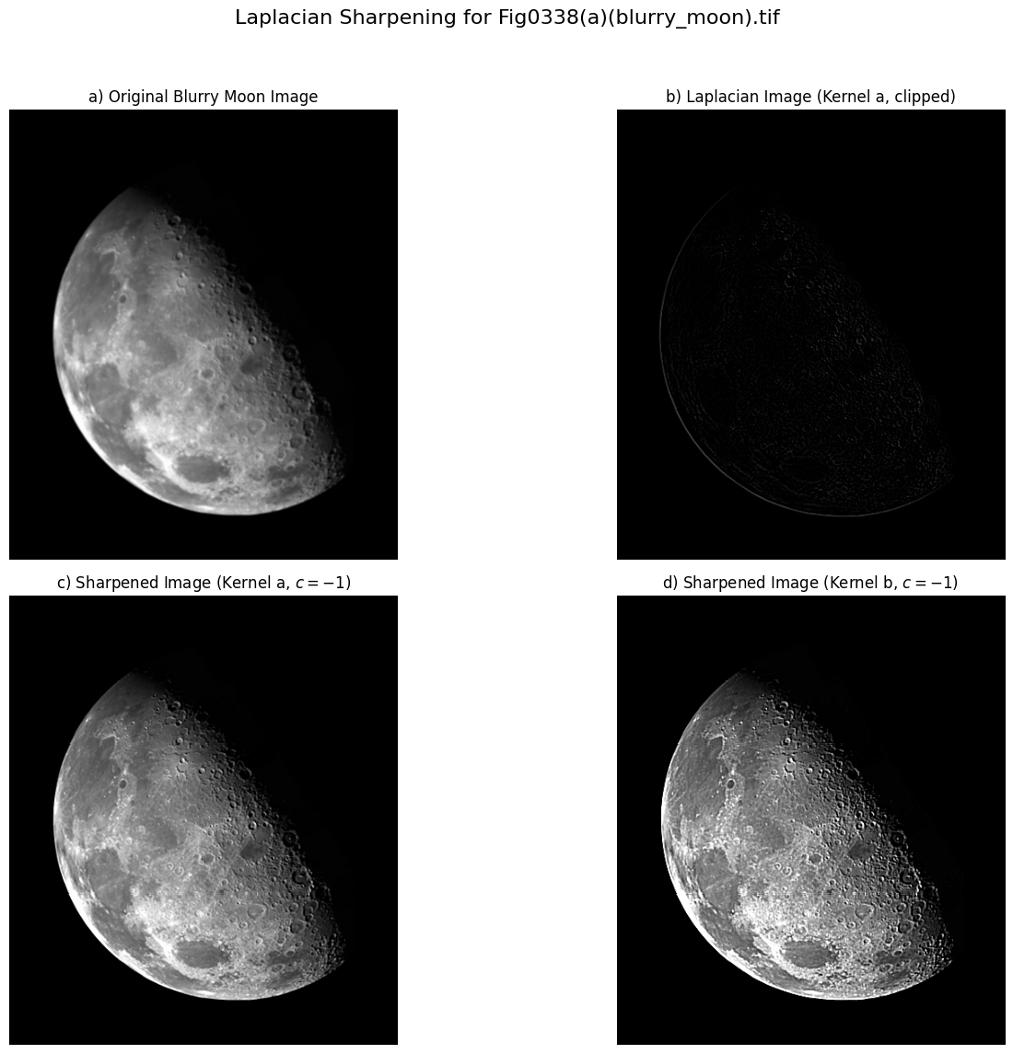

**Homework: Implement Figure 3.46 by programming with Python**

Python Code:

**import** numpy as np

**import** imageio.v2 as imageio

**import** matplotlib

matplotlib.use('Agg')

**import** matplotlib.pyplot as plt

**import** os

**from** scipy.ndimage **import** convolve

**def** apply_sobel_gradient(image):

    """

    Applies Sobel operators to compute the gradient magnitude of an image

    """

    sobel_x **=** np.array([

        [**-**1, 0, 1],

        [**-**2, 0, 2],

        [**-**1, 0, 1]

    ], dtype**=**float)

    sobel_y **=** np.array([

        [**-**1, **-**2, **-**1],

        [ 0,  0,  0],

        [ 1,  2,  1]

    ], dtype**=**float)

    image_float **=** image.astype(float)

    Gx **=** convolve(image_float, sobel_x, mode**=**'nearest')

    Gy **=** convolve(image_float, sobel_y, mode**=**'nearest')

    gradient_magnitude **=** np.sqrt(Gx**\*\***2 **+** Gy**\*\***2)

    max_val **=** np.max(gradient_magnitude)

**if** max_val > 0:

        scaled_gradient_magnitude **=** (gradient_magnitude **/** max_val **\*** 255)

**else**: # Handle case where image is uniform (no edges)

        scaled_gradient_magnitude **=** np.zeros_like(gradient_magnitude)

    final_gradient_image **=** np.clip(scaled_gradient_magnitude, 0, 255).astype(np.uint8)

**return** final_gradient_image

**if** __name__ **==** "__main__":

    # Define input and output directories

    input_dir **=** "original_image"

    output_dir **=** "output_image"

    os.makedirs(output_dir, exist_ok**=**True)

    image_filename **=** "Fig0342(a)(contact_lens_original).tif"

    image_path **=** os.path.join(input_dir, image_filename)

    base_name **=** os.path.splitext(image_filename)[0]

    original_image **=** imageio.imread(image_path)

    gradient_image **=** apply_sobel_gradient(original_image)

    # Visualization

    plt.figure(figsize**=**(12, 6))

    plt.suptitle(f'Gradient Edge Enhancement for {image_filename}', fontsize**=**16)

    plt.subplot(1, 2, 1)

    plt.imshow(original_image, cmap**=**'gray', vmin**=**0, vmax**=**255)

    plt.title('a) Original Contact Lens Image')

    plt.axis('off')

    plt.subplot(1, 2, 2)

    plt.imshow(gradient_image, cmap**=**'gray', vmin**=**0, vmax**=**255)

    plt.title('b) Sobel Gradient Magnitude')

    plt.axis('off')

    plt.tight_layout(rect**=**[0, 0.03, 1, 0.95]) # Adjust layout to prevent title overlap

    combined_output_path **=** os.path.join(output_dir, f"{base_name}_gradient_enhancement_results.png")

    plt.savefig(combined_output_path, bbox_inches**=**'tight')

    plt.close()

Output Images”

